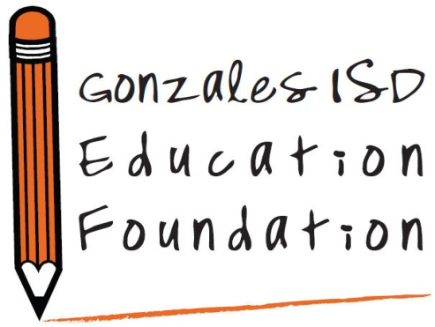

2019-2020 EDUCATION TEACHING GRANTS

TIMELINE

August 6 School Convocation

August 16 Teacher Vendor Fair

August 26 Education Foundation Board of Directors Meeting

September 4 & 5 Mandatory Grant Workshop, 4:15, Gonzales High School Library,

Grant writing training for all interested in applying

September 9 Grants opened for application

October 8 Grants Due to contact person @ GISD Central Office (Lucy Pena)

by 4pm

October 16 Grant notebooks submitted to Grant Raters

October 24 Grant Raters return grant notebooks to GISD Central Office

November 4 Education Foundation Board of Directors Meeting – review

grant ratings and vote for grant awards

Month of December Grants awarded (Approximate Date)